Smart Home Switches

**

Student’s name:

Amaan Majeed F2020266286

Usaid Afzal F2020266271

M. Hashim F2020266272

Section: V7

Course title: Digital Logic Design

Resource person: Mahwish Shahid

**University of Management and Technology, Lahore**

**Table of Contents**

1. Introduction 1

1.1 Project Overview 1

1.1.1 Uses 1

1.1.2 Advantages 1

1.2 Problem Statement 1

1.3 Functionality 1

2. Implementation 2

2.1 Components 2

2.1.1 List of components 2

2.1.2 Components description 2

2.2 Schematic Diagram 2

2.2.1 List of inputs / Output 3

2.3 Project Diagram 3

2.3.1 Procedure: 3

# Introduction

The Home Automation System was made with Arduino based microcontroller Node-MCU coupled with a relay board and a few jumper cables. To top everything the output is presented in a way that shows how to project works and how the appliances can turn on/off according to the instruction we give to it.

## Project Overview

The Project is centered towards the people who are disabled at the age where they are unable to go to the switch outlet manually and turn light or fan on. This product eliminates the need to physically approach an outlet. The device is programmed in a way which helps the user to turn the appliance on by just saying the command (With the help of Amazon Alexa) or toggling it through the web browser which is easily accessible through a smart phone/laptop/ Tablet.

Other than that, this product serves a great purpose for a normal user as well. Imagine turning the light off without even getting up from you seat when you are really tired at night. Now with just a push of a button that dream is possible.

### Uses

* Turn electrical appliances remotely
* No need to physically get up to turn your lights off
* Remotely access it from anywhere in the world

### Advantages

* No need to get up physically
* Accessible through Phone/Laptop/Table/Amazon Alexa

## Problem Statement

This aims to break the barrier between a normal person and a disabled person, ultimately making them less dependent on others to control their life.

## Functionality

The product is used for smart home purposes which can be used with or without internet if connected to Home Assistant. The project currently has the capability to turn the switches on and off basically acting as an extension cable for your Electrical Appliances. They turn on by your smartphone, Laptop, or Tablet. You can also pair you Amazon echo device to further enhance the experience.

# Implementation

## Components

### List of components

1. Node-MCU
2. Relay Board
3. Jumper Wires
4. Micro USB Cable
5. Switches
6. Amazon Alexa (Optional)

### Components description

1. **Node-MCU**: Node mcu is an Arduino based micro controller which has Wi-Fi chip esp8266 attached to it giving us access to GPIO pins to interact with the chip itself.
2. **Relay Board**: Relay board is a series of relays connected together. Relay is a magnet-based switch which is usually operated at 5v. They receive commands in signals to operate the switches and the voltage provided to them completes the circuit according to the signal, hence turning the circuit on/off.
3. **Amazon Alexa**: Even though an optional device this would help you a lot with the experience of interacting with this project. Amazon Alexa is an everyday utility device with specializes in smart Home control.

## Schematic Diagram

### Circuit Diagram

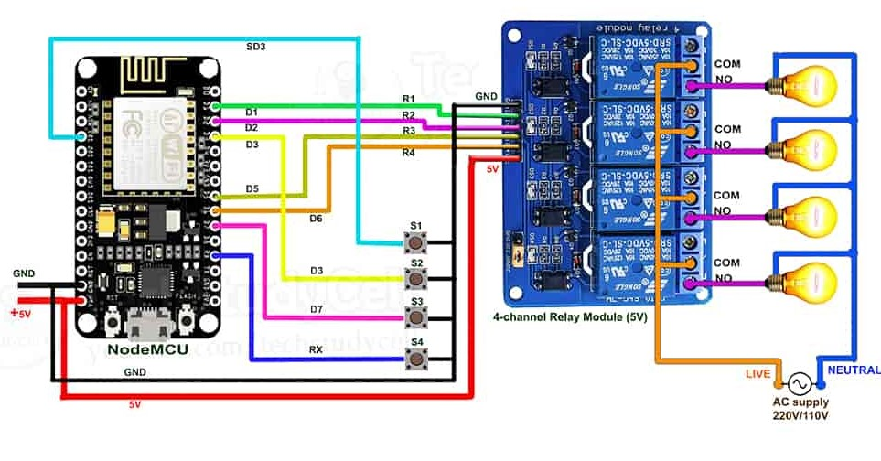

### List of inputs / Output

1. Relay 1: D1
2. Relay 2: D2
3. Relay 3: D3
4. Relay 4: D4
5. Switch 1: D5
6. Switch 2: D6
7. Switch 3: D7

### Procedure:

1. Gather around all the components in the list
2. Go to the web browser and search for the latest tasmota firmware
3. Download the “tasmota.bin” file and the tasmota software itself
4. Open the software and plug your microcontroller to your computer
5. Press refresh in Select Port menu, it would automatically select the port for the board
6. Select the “self-resetting device” option
7. Upload the file and click the button which says “Tasmotize!”
8. Wait for it to upload then press on “Send config”
9. Enter your Wi-Fi Credentials and press save
10. Wait for about 5 to 10 seconds and press on “Get IP”
11. Copy the IP-Address for the field
12. Open your browser and paste the IP-Address you copied
13. Go to Configuration -> Configure Module -> select Generic (0) from the Module type
14. Click on save, Go to main Menu
15. Go to Configuration -> Configure Module -> and select the pins mentioned in 2.2.2
16. Press save and go to Main Menu

If you did everything as mentioned then you would to their main page with 4 toggle switches on the top. They can toggle on and off but nothing would happen as if yet. Open all your equipment and make the circuit as mentioned in the diagram 2.2.1. Connect the power supply and you are ready to go.

### Setting up Alexa:

Now if you want to connect this to you amazon echo and have voice controls then follow the procedure:

1. Go to Configure -> Configure Other -> Enter the Project name / Switch names
2. In Emulation select Hue Bridge and press save
3. Open your Amazon Alexa app and add devices
4. Follow the procedure in the app and you would be prompted with 4 devices
5. Set them up through the app

If everything done correctly, you would now be able to control your device through the Amazon Alexa app, as well as your voice as an input.